بسمه تعالی
فرم چکیده سخنرانی ژورنال کلاب دانشجویان دکترا ورودی
دانشکده بهداشت – گروه مهندسی بهداشت محیط

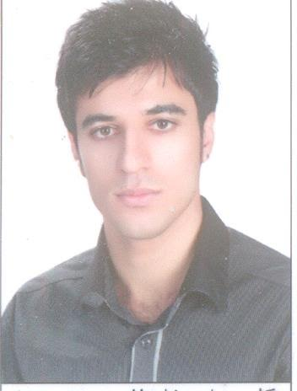
نام و نام خانوادگی دانشجو : مرتضی سیفی شماره دانشجویی: 9321150002

استاد راهنمای آموزشی: دکتر فضل الله چنگانی عکس دانشجو:

تاریخ : 12/06/96 ساعت: 10

عنوان مقاله :
“Removal of styrene using dielectric barrier discharge plasmas combined
with sol–gel prepared TiO2 coated c-Al2O3”

چکیده :
TiO2 coated c-Al2O3 prepared by sol–gel method (SG/c-Al2O3) were filled in a dielectric barrier discharge
(DBD) reactor to remove styrene which is a typical VOC with high toxicity and odorous smell. Compared
with traditional commercial P25 TiO2 powder coated c-Al2O3 (P25/c-Al2O3), TiO2 loading quantity could
be controlled with different coating times by sol–gel method. However for P25/c-Al2O3, the loading
quantity was difficult to be increased because P25 would easily fall off when the coating film got thicker.
The calcination temperature and coating times were optimized in this research. The results showed that
the SG/c-Al2O3 calcined at 550 C owned the best catalytic activity and the carbon deposition on catalyst
surface could be efficiently reduced with increase of TiO2 loading quantity, while large amount of carbon
deposition was observed on P25/c-Al2O3. Meanwhile O3 decrease efficiency also improved from 18% with
P25/c-Al2O3 to 36% with SG/c-Al2O3 and less O3 was detected in outlet gas. Other factors like specific
input energy (SIE) and oxygen content were also investigated and optimized. When the applied voltage
was 12.5 kV, 100% O2 flowed, the selectivity of CO and CO2 could reach 100% and nearly no carbon deposition could be observed on TiO2 surface. Additionally, the formation of by-products, including NOx, in the reaction system and the plausible reaction mechanism of DBD combined with TiO2 catalyst were also
detected and discussed.

